The Importance of Social Emotional Learning, for ALL Students across ALL Grades

Social and Emotional Learning (SEL) is the process through which children and adults acquire and effectively apply the knowledge, attitudes, and skills necessary to understand and manage emotions, establish and achieve positive goals, feel and show empathy for others, establish and maintain positive relationships and make responsible decisions. SEL is critical to developing competencies besides academic content knowledge that are necessary to succeed in college and in careers. Effective SEL programming begins in preschool and continues through high school.
SEL programming is based on the understanding that the best learning emerges in the context of supportive relationships that make learning challenging, engaging, and meaningful.
Social and emotional skills are critical to being a good student, citizen, and worker. Workforce demands aside, many call for the 21st century classroom to be student-centered and to support individual learning needs. Moreover, students’ ability to learn well depends not just on instruction but also on factors such as the school climate, a sense of belonging with peers, positive relationships with educators, and the feedback they receive. Neuroscience research demonstrates that emotion and cognition are inextricably linked; emotions are critical for all people to understand, organize and make connections between even “pure” academic concepts.
Many risky behaviors (e.g., drug use, violence, bullying, and dropping out) can be prevented or reduced when multiyear, integrated efforts are used to develop students' social and emotional skills. This is best done through effective classroom instruction, student engagement in positive activities in and out of the classroom, and broad parent and community involvement in program planning, implementation, and evaluation.
As Maurice Elias, the head of Rutgers University’s Social Emotional Learning Lab, has stated, schools have a “moral and ethical imperative” to take responsibility for students’ well-being, not just their academic knowledge.

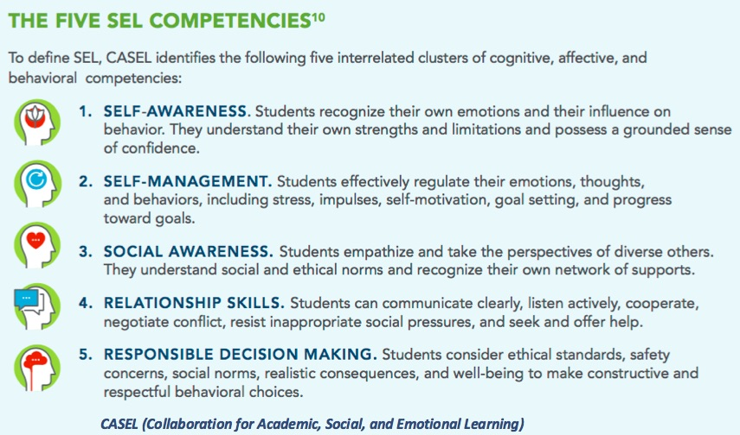

Outcomes Associated with the Five Competencies

The short-term goals of SEL programs are to:
- promote students’ self-awareness, self- management, social-awareness, relationship and responsible decision-making skills
- improve student attitudes and beliefs about self, others, school, and community.
These, in turn, provide a foundation for better adjustment and academic performance as reflected in more positive social behaviors and peer relationships, fewer conduct problems, less emotional distress, improved grades and test scores.

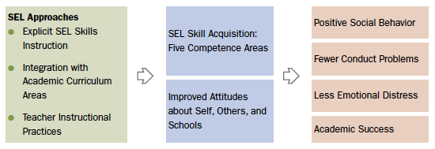
There is a growing awareness in the U.S. among educators and policymakers about the importance of social and emotional development for successful student performance especially in preschool and elementary school. The five sets of SEL competencies are important from very early in life but are especially relevant as children begin to spend time with adults outside the home and to socialize with peers.
Social and emotional skills play a role in determining how well-equipped children will be to meet the demands of the classroom and if they are able to engage fully in learning and benefit from instruction.

Social Emotional Leaning across Multi-Tiered Systems of Support (MTSS)
“For SEL skills applied for students at the Tier 1 level, the access to these skills is embedded within the authentic curricula. Some students may need more specific skill training and practice utilizing Tier 2 and Tier 3 interventions (such as small group or individual situations, settings or programs). “
Mosley, IDEA Resource CADRE, 2016

Powerful Evidence Supporting the Impact of Enhancing Students' SEL
Research shows that SEL can have a positive impact on school climate and promote a host of academic, social, and emotional benefits for students. Durlak, Weissberg et al.’s recent meta-analysis of 213 rigorous studies of SEL in schools indicates that students receiving quality SEL instruction demonstrated:
- better academic performance: achievement scores an average of 11 percentile points higher than students who did not receive SEL instruction;
- improved attitudes and behaviors: greater motivation to learn, deeper commitment to school, increased time devoted to schoolwork, and better classroom behavior;
- fewer negative behaviors: decreased disruptive class behavior, noncompliance, aggression, delinquent acts, and disciplinary referrals; and
- reduced emotional distress: fewer reports of student depression, anxiety, stress, and social withdrawal.

Resources

www.CASEL.org The Missing Piece
A National Teacher Survey on How Social and Emotional Learning Can Empower Children and Transform Schools
www.ASCD.org/ASCD/pdf/siteascd/policy/sel_policybrief_final_11-16-15.pdf

